**1.Get column info & structure:**

select data_type,column_name

from information_schema.columns

where table_name='data_cleaned'

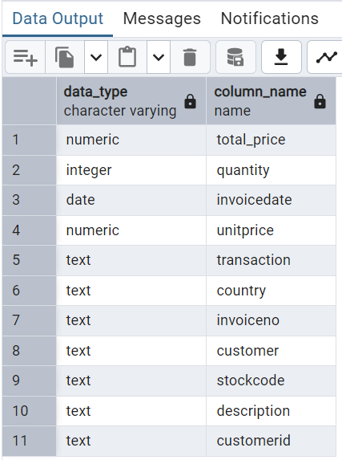

**2.Total number of rows (observations):**

select count(*) from data_cleaned

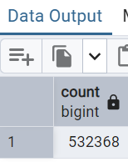

**3.Top 10 selling products by total revenue:**

select total_price from data_cleaned

order by total_price desc

limit 10

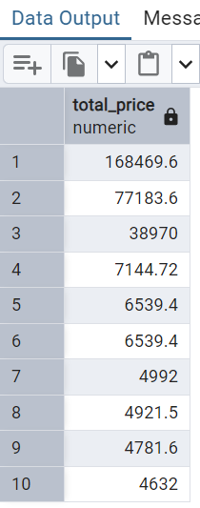

**4.total revenue per day:**

select invoicedate :: date as daily_sales,sum(total_price) as total_revenue from data_cleaned

group by daily_sales

order by daily_sales

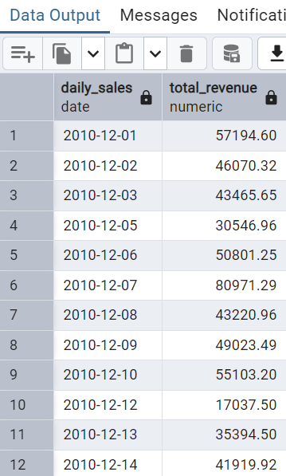

**5.total quantity sold per day:**

select invoicedate :: date as daily_sales, sum(quantity) as total_quantity from data_cleaned

group by invoicedate :: date

order by daily_sales

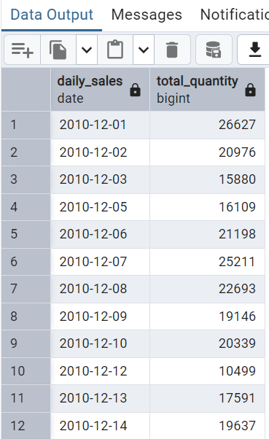

**6**. **Sales by country:**

select country , sum(total_price) as total_price from data_cleaned

group by country

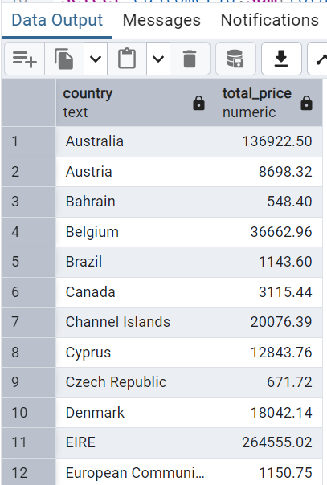

**7.** **Top customers by revenue:**

select customerid,sum(total_price) as total_revenue from data_cleaned

where customerid is not null

group by customerid

order by total_revenue desc

limit 10

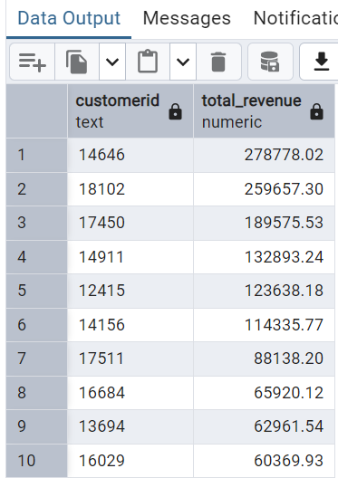

**8**. **Detecting returns or negative transactions:**

select * from data_cleaned

where quantity<0

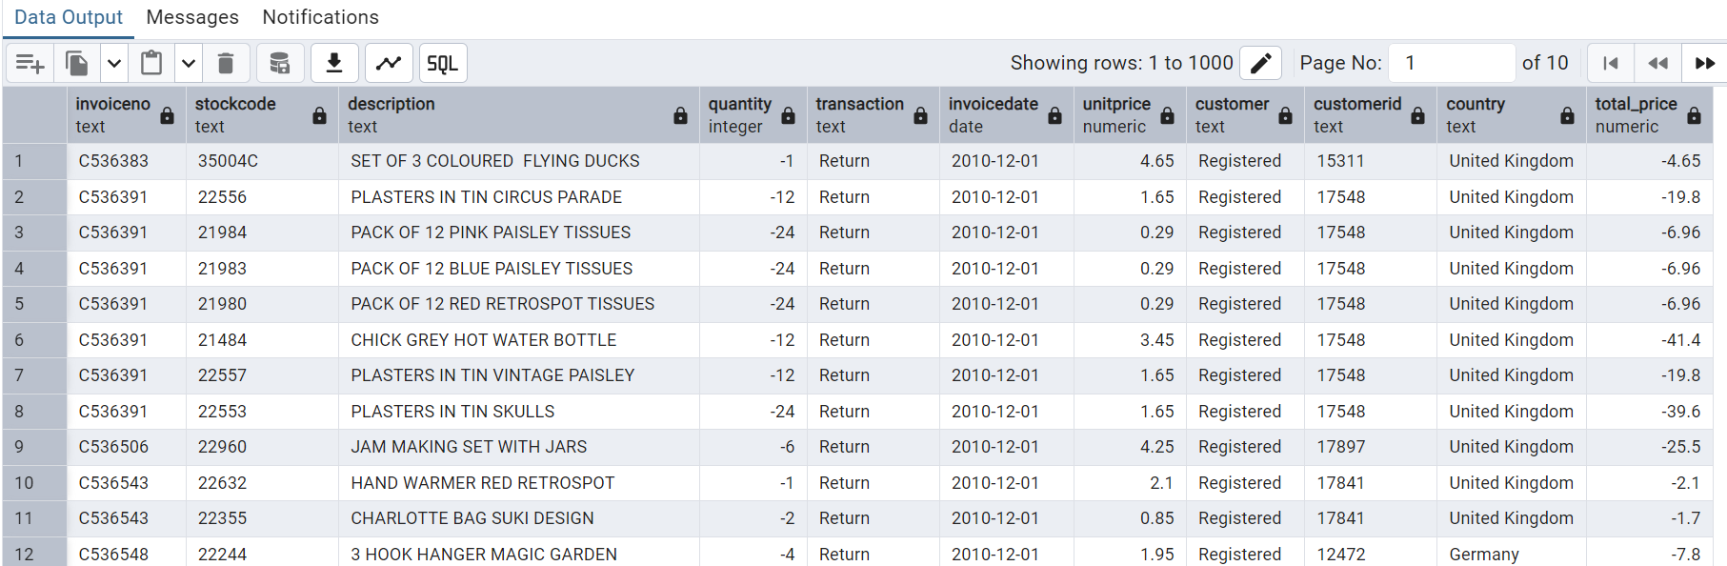

**9**. **Valid transactions only (filtering returns):**

select * from data_cleaned

where quantity>0

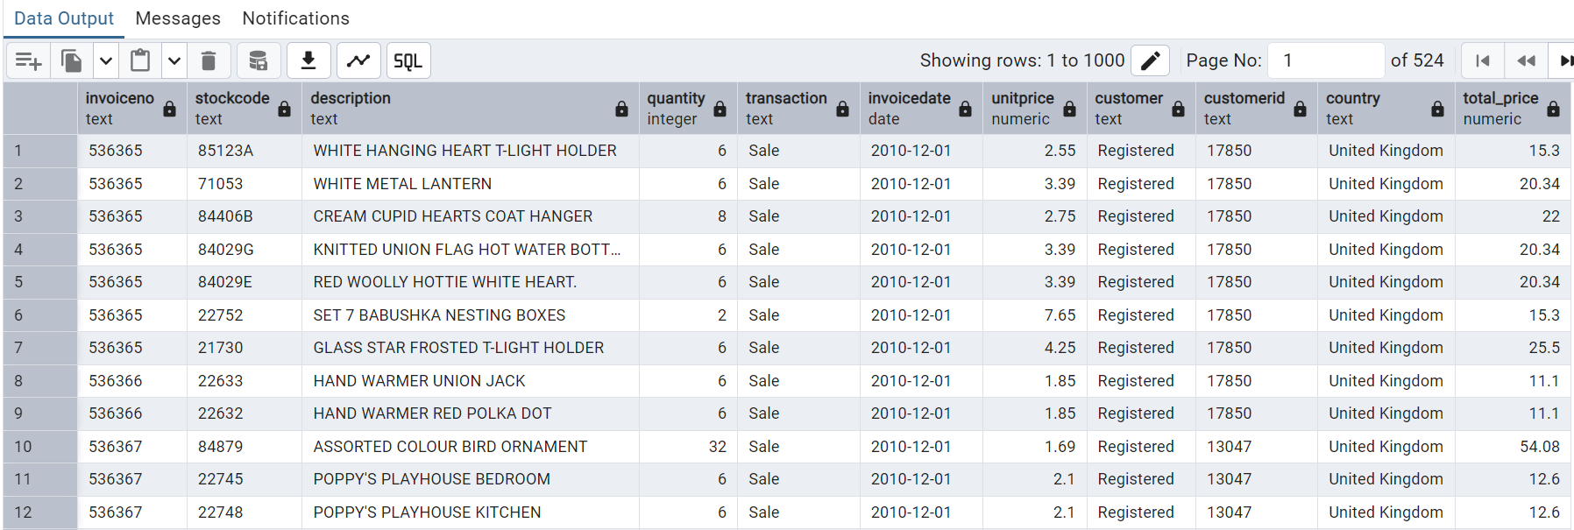

**10. Monthly Sales Trend:**

select date_trunc('month',invoicedate) as month,

round(sum(total_price),2) as monthly_revenue from data_cleaned

where quantity>0

group by month

order by month

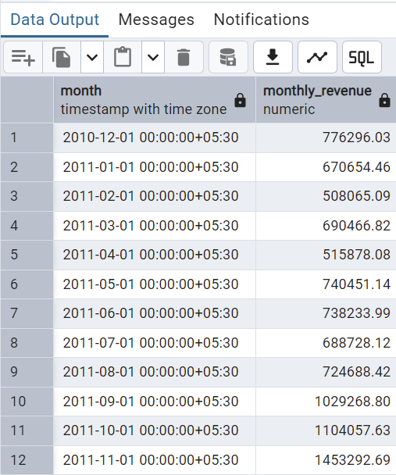

**11. Basket Size (Average quantity per order)**

select invoiceno,sum(quantity) as total_items from data_cleaned

group by invoiceno

order by total_items desc

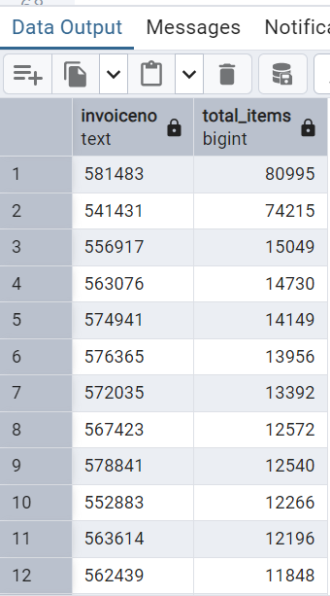

**12. Average Order Value (AOV)(quantity wise)**

select round(avg(order_value),2) as avg_order_value

from(

select invoiceno,sum(quantity) as order_value

from data_cleaned

where quantity>0

group by invoiceno

)as subquery

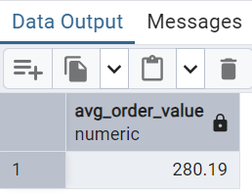

**13. Average Order Value (AOV)**

select round(avg(order_value),2) as avg_order_value

from(

select invoiceno,sum(total_price) as order_value

from data_cleaned

where quantity>0

group by invoiceno

)as subquery

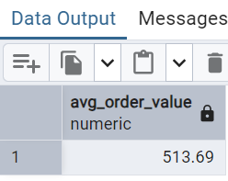

**14. Most Returned Products**

select description,count(*) as return_count

from data_cleaned

where quantity<0

group by description

order by return_count desc

limit 10

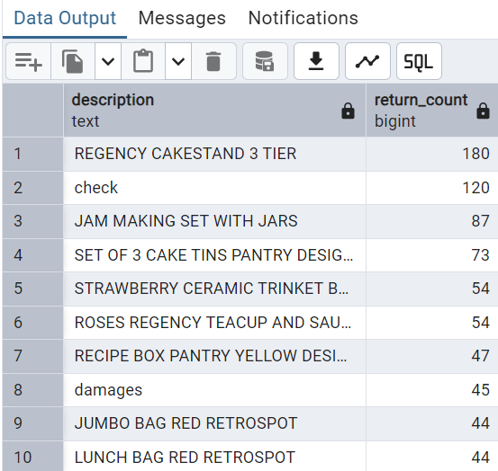

**15. Customer Segmentation by Spend:**

select customerid, sum(total_price) as total_spent,

count(distinct invoiceno) as total_orders

from data_cleaned

where customerid is not null

group by customerid

order by total_spent desc

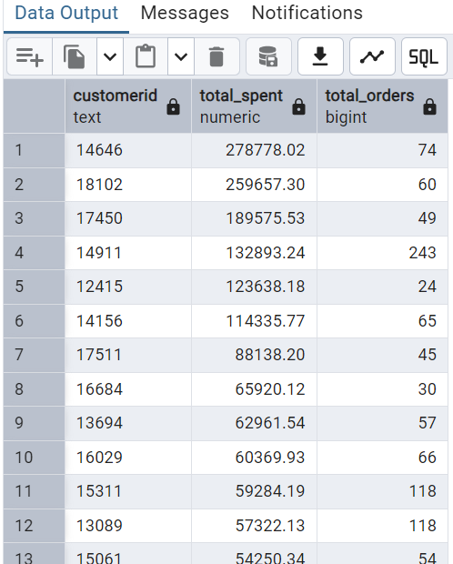

**16. Top Products Per Country:**

select country,description,sum(quantity) as total_orders

from data_cleaned

group by 1,2

order by 1,3 desc

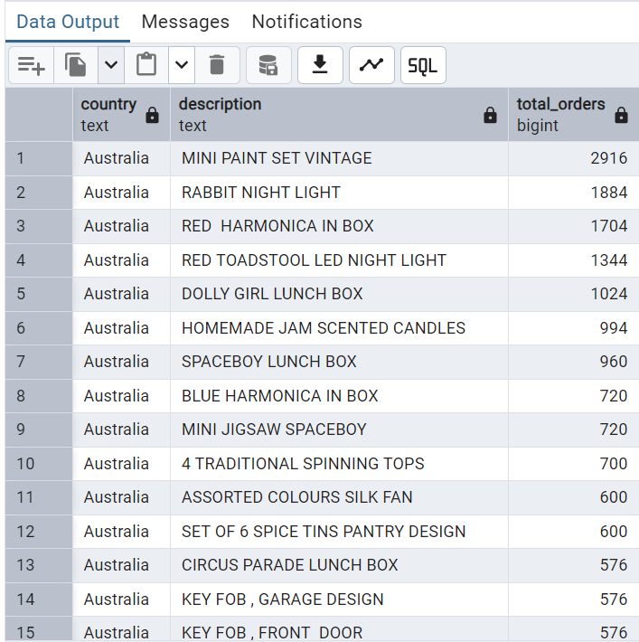

**17. Day of Week Sales Trend**

select

to_char(invoicedate,'Day') as day_of_week,

sum(total_price) as revenue

from data_cleaned

where quantity>0

group by day_of_week

order by day_of_week desc

